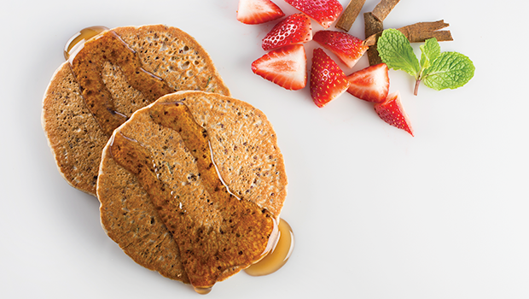
Red Quinoa Pancake
Red Quinoa
Pancake mix
Whole flour mix
Cinnamon
Dried Apricot
Maple syrup
Strawberries
Nutrition Facts: 1 pancake
CALORIES | PROTEIN | CARBS | FAT | Fiber | SODIUM
185 Cal | 4.5 g | 39 g | 2 g | 3 g | 185 mg

Red Quinoa Pancake
Red Quinoa
Pancake mix
Whole flour mix
Cinnamon
Dried Apricot
Maple syrup
Strawberries
Nutrition Facts: 1 pancake
CALORIES | PROTEIN | CARBS | FAT | Fiber | SODIUM
185 Cal | 4.5 g | 39 g | 2 g | 3 g | 185 mg

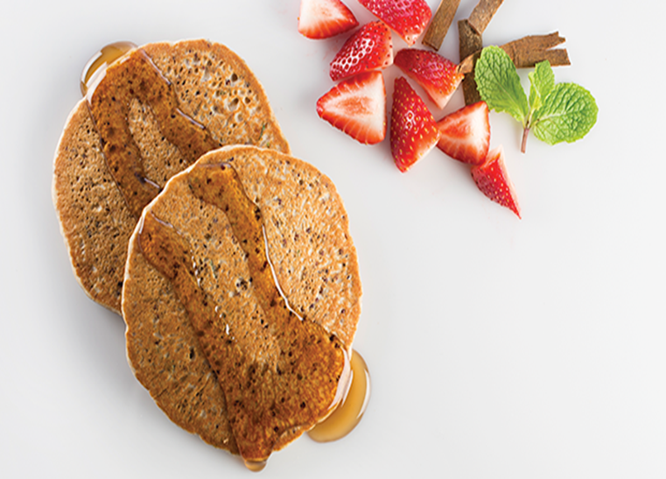
Red Quinoa Pancake
Red Quinoa Pancake
Red Quinoa
Pancake mix
Whole flour mix
Cinnamon
Dried Apricot
Maple syrup
Strawberries
Nutrition Facts: 1 pancake
CALORIES | PROTEIN | CARBS | FAT | Fiber | SODIUM
185 Cal | 4.5 g | 39 g | 2 g | 3 g | 185 mg

Red Quinoa Pancake
Red Quinoa
Pancake mix
Whole flour mix
Cinnamon
Dried Apricot
Maple syrup
Strawberries
Nutrition Facts: 1 pancake
CALORIES | PROTEIN | CARBS | FAT | Fiber | SODIUM
185 Cal | 4.5 g | 39 g | 2 g | 3 g | 185 mg

Red Quinoa Pancake
Yields 1 pancake

Preparation

Yields 1 pancake

- Prepare Red Quinoa according to recipe:
- Bring water to a boil. Add quinoa, stir to combine. Return to a boil. Cover. Reduce heat and simmer for 10-15 minutes or until water is fully absorbed. Do not stir. Let quinoa sit for 5 minutes. Fluff with a fork.
- Pour water into large mixing bowl
- Combine pancake mix, wheat flour and cinnamon. Add water, mixing well until batter is smooth
- Fold in quinoa, apricots and mint until ingredients are blended
- Spray skillet with vegetable oil and ladle 2 oz. of batter into the hot skillet.
- Grilled for 1 or 2 minutes on each side or until golden brown and edges begin to dry
- Remove from pan and serve immediately with 1Tbsp of maple syrup and ½ cup fresh strawberries.
- Prepare Red Quinoa according to recipe:
- Bring water to a boil. Add quinoa, stir to combine. Return to a boil. Cover. Reduce heat and simmer for 10-15 minutes or until water is fully absorbed. Do not stir. Let quinoa sit for 5 minutes. Fluff with a fork.
- 2. Pour water into large mixing bowl
- 3. Combine pancake mix, wheat flour and cinnamon. Add water, mixing well until batter is smooth
- 4. Fold in quinoa, apricots and mint until ingredients are blended
- 5. Spray skillet with vegetable oil and ladle 2 oz. of batter into the hot skillet.
- 6. Grilled for 1 or 2 minutes on each side or until golden brown and edges begin to dry
- 7. Remove from pan and serve immediately with 1Tbsp of maple syrup and ½ cup fresh strawberries
Ingredients
Ingredients

- ¼ ounce Red Quinoa, raw
- 3 oz. water
- 1 ½ ounce pancake mix
- ¼ ounce Red Quinoa, raw 3 oz. water
- 1 ½ ounce pancake mix
- ¾ ounce whole wheat flour
- 1/8 teaspoon cinnamon
- 1/3 ounce dried apricot
- 1 Tablespoon maple syrup
- 4 strawberries quartered
- Fresh

- ¾ ounce whole wheat flour
- 1/8 teaspoon cinnamon
- 1/3 ounce dried apricot
- 1 Tablespoon maple syrup
- 4 strawberries quartered
- Fresh

Preparation

Preparation
Red Quinoa Pancake
Red Quinoa Pancake
Yields 1 pancake
Preparation

- Prepare Red Quinoa according to recipe:
- Bring water to a boil. Add quinoa, stir to combine. Return to a boil. Cover. Reduce heat and simmer for 10-15 minutes or until water is fully absorbed. Do not stir. Let quinoa sit for 5 minutes. Fluff with a fork.
- 2. Pour water into large mixing bowl
- 3. Combine pancake mix, wheat flour and cinnamon. Add water, mixing well until batter is smooth
- 4. Fold in quinoa, apricots and mint until ingredients are blended
- 5. Spray skillet with vegetable oil and ladle 2 oz. of batter into the hot skillet.
- 6. Grilled for 1 or 2 minutes on each side or until golden brown and edges begin to dry
- 7. Remove from pan and serve immediately with 1Tbsp of maple syrup and ½ cup fresh strawberries
Yields 1 pancake
- Prepare Red Quinoa according to recipe:
- Bring water to a boil. Add quinoa, stir to combine. Return to a boil. Cover. Reduce heat and simmer for 10-15 minutes or until water is fully absorbed. Do not stir. Let quinoa sit for 5 minutes. Fluff with a fork.
- 2. Pour water into large mixing bowl
- 3. Combine pancake mix, wheat flour and cinnamon. Add water, mixing well until batter is smooth
- 4. Fold in quinoa, apricots and mint until ingredients are blended
- 5. Spray skillet with vegetable oil and ladle 2 oz. of batter into the hot skillet.
- 6. Grilled for 1 or 2 minutes on each side or until golden brown and edges begin to dry
- 7. Remove from pan and serve immediately with 1Tbsp of maple syrup and ½ cup fresh strawberries

Ingredients
Ingredients
- ¼ ounce Red Quinoa, raw 3oz water
- 1 ½ ounce pancake mix
- ¾ ounce whole wheat flour
- 1/8 teaspoon cinnamon
- 1/3 ounce dried apricot
- 1 Tablespoon maple syrup
- 4 strawberries quartered
- Fresh

- ¼ ounce Red Quinoa, raw
- 3oz. water
- 1 ½ ounce pancake mix
- ¾ ounce whole wheat flour
- 1/8 teaspoon cinnamon
- 1/3 ounce dried apricot
- 1 Tablespoon maple syrup
- 4 strawberries quartered
- Fresh

