Eat Smart & Move More
Wilson Sanchez

Carbohydrate Counting for People with Diabetes
Why Is Carbohydrate Counting Important?
- Counting carbohydrate servings may help you control your blood glucose level so that you feel better.
- The balance between the carbohydrates you eat and insulin determines what your blood glucose level will be after eating.
- Carbohydrate counting can also help you plan your meals.

Carbohydrate Servings
In diabetes meal planning, 1 serving of a food with carbohydrate has about 15 grams of carbohydrate:
- Check serving sizes with measuring cups and spoons or a food scale.
- Read the Nutrition Facts on food labels to find out how many grams of carbohydrate are in foods you eat.
- The food lists in this handout show portions that have about 15 grams of carbohydrate.
Food Lists for Carbohydrate Counting
1 serving = about 15 grams of carbohydrates

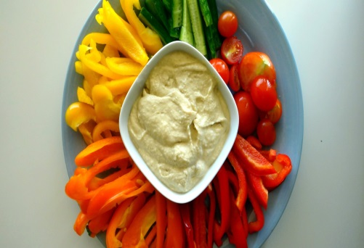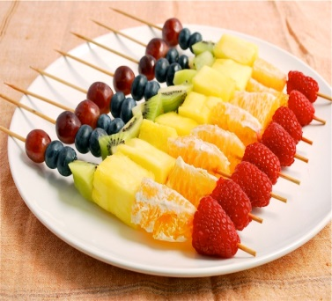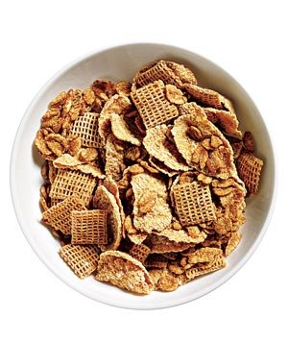

15 grams of carbs snack list

Fruit
Apple, small, 2” | Cherries, 12 | Kiwi
Banana, extra-small, 4 ounces | Dates, 3 | Mango, cubed, 1/2 cup
Apricots, 5.5 oz | Figs, 2 medium | Nectarine, small
Blueberries or Blackberries, 3/4 cup | Grapefruit, large, 1/2 | Orange, small
Cantaloupe, honeydew, papaya, cubed, 1 cup | Grapes, small, 3 oz or about 17 | Peach, medium
Pear, large, 1/2 | Plums, small, 5 ounces | Strawberries, 1 1/4 cup
Pineapple, cubed, 3/4 cup | Raspberries, 1 cup | Tangerines, small, 8 oz.
Watermelon, cubed, 1 1/4 cup

Vegetables (typically 1.5 cups of cooked or 3 cups raw)
Amaranth | Baby corn | Borscht
Artichoke | Bamboo shoots | Broccoli
Artichoke hearts | Bean sprouts | Brussels sprouts
Asparagus | Beets | Cabbage
Carrots | Cucumber | Jicama
Cauliflower | Eggplant | Kohlrabi
Celery | Green beans | Leeks
Chayote | Green onions or scallions | Mung bean sprouts
Mushrooms | Peppers, all varieties | Rutabaga
Okra | Radishes | Rutabaga Soybean sprouts
Oriental radish or daikon | Rutabaga | Spinach
Sugar snap peas | Turnips | Zucchini
Summer squash | Water chestnuts | Swiss chard
Tomato

Dairy
8 oz. Milk | 1/2 cup Yogurt
8 oz. Chocolate Milk | Frozen yogurt
8 oz. Soy Milk | 1 cup unflavored Rice drink

Packaged Snacks
5 Triscuits | Jell-O Sugar Free puddings | 2 Rice Cakes

Other Fun Stuff (combination provides 15 to 20 grams of carbs)
1⁄2 cup Jell-O sugar-free  pudding, any flavor  1⁄2 of a small banana, sliced | Greek yogurt with berries or a dash of balsamic vinegar | Pickles
Small tortilla pizza | 10 Wheat Thins Reduced-Fat crackers  2 pieces Weight Watchers Natural  Reduced Fat Cheddar Cheese Snacks | Hard-boiled egg with a piece of watermelon or peach
1 4-inch whole wheat pita pocket, torn into pieces (1oz.)  2 tablespoons Athenos Original Hummus | Hummus and veggies | ½ coleslaw
½ large pear with 1 oz. president light brie cheese | 1⁄2 of a Thomas’ 100% Whole Wheat Bagel Thin  1 slice Kraft Reduced Fat Swiss Cheese  1 slice Oscar Mayer Deli Fresh Oven Roasted  Turkey Breast | 3 slices Old London Salt Free Whole Grain Melba Toast  1⁄4 cup low-fat ricotta cheese  Freshly ground black pepper
1 small apple with 2 Tsps. PB2 powdered peanut butter, prepared. | 1⁄2 of a small banana, split lengthwise  1 tablespoon peanut butter  2 teaspoons crushed cornflakes cereal  1 teaspoon flaked coconut | 1⁄2 of an Earth Grains 100% Whole Wheat Thin Bun  1 tablespoon pizza sauce  1⁄2 cup thinly sliced vegetables  1⁄4 cup shredded part-skim mozzarella cheese  Sliced fresh basil or dried oregano
1 cup raw carrot chips with a 4 oz. carton Breakstone’s Snack Size, Small Curd Low-fat Cottage Cheese | 1 medium orange, peeled and  sliced into rounds  Dash of ground cinnamon | 1 mini box Sun-Maid Raisins  2 tablespoons Eden Organic Dry  Roasted Pumpkin Seeds

Desserts
Small brownie | 2” chocolate chip cookie

Resources
- American Diabetes Association. (2014). Choose Your Foods. Food Lists for Weight Management
- Academy of Nutrition and Dietetics. (2015). Carbohydrates Counting for People with Diabetes

